**Project Report On**

**PATHIK**

**Submitted in Partial fulfillment for the award of degree of Bachelor of Engineering in Computer Science and Engineering**



**Rajiv Gandhi Proudyogiki Vishwavidyalaya, Bhopal(M.P.)**

**Submitted By:**

**Aadarsh Shrivastava (0126CS191001)**

**Kaustubha Chaturvedi(0126CS191045)**

**Dev Raghuvanshi (0126CS191035)**

**Deep Raghuvanshi (0126CS191033)**

**Under the Guidance of Professor Priyanka Mishra Department of Computer Science & Engineering**



**ORIENTAL COLLEGE OF TECHNOLOGY, BHOPAL Approved by AICTE New Delhi & Govt. of M.P. Affiliated to Rajiv Gandhi Proudyogiki Vishwavidyalaya, Bhopal (M.P.) Session: 2020-21**

**CERTIFICATE**

###### This is to certify that the work embodied in this Project, Dissertation Report entitled as “Pathik” being Submitted by Aadarsh Shrivastava(0126cs191001), Kaustubha Chaturvedi(0126cs191045),Deep Raghuvanshi (0126cs191033) and Dev Raghuvanshi (0126CS191035) in partial fulfillment of the requirement for the award of “Bachelor of Technology ” in Computer Science & Engineering discipline to Rajiv Gandhi Proudyogiki Vishwavidyalaya, Bhopal (M.P.) during the academic year 2020-21 is a record of bonafide piece of work, carried out under my supervision and guidance in the Department of Computer Science & Engineering, Oriental College of Technology, Bhopal.

**Approved By:-**

Prof Priyanka Mishra - Guide Prof

Amit Dubey - Head of Department

Dr. Amita Mahor - Director

**CERTIFICATE OF APPROVAL**

This Project “Pathik” being submitted by Aadarsh Shrivastava(0126cs191001), Kaustubha Chaturvedi(0126cs191045),Deep Raghuvanshi (0126cs191033) and Dev Raghuvanshi (0126CS191035) has been examined by me & hereby approve for the partial fulfillment of the requirement for the award of “Bachelor of Technology in Computer Science & Engineering” for which it has been submitted. It is understood that by this approval the undersigned do not necessarily endorse or approve any statement made, opinion expressed or conclusion drawn therein, but the Project only for the purpose for which it has been submitted.

INTERNAL EXAMINER EXTERNAL EXAMINER Date: Date:

**CANDIDATE DECLARATION**

We hereby declare that the Project dissertation work presented in the report entitled as “Pathik” submitted in the partial fulfillment of the requirements for the award of the degree of Bachelor of Engineering in Computer Science & Engineering of Oriental College of Technology is an authentic record of our own work. We have not submitted the part and partial of this report for the award of any other degree or diploma.

Aadarsh Shrivastava(0126cs191001),

Kaustubha Chaturvedi(0126cs191045)

,Deep Raghuvanshi (0126cs191033)

Dev Raghuvanshi (0126CS191035)

Date: This is to certify that the above statement made by the candidates is correct to the best of my knowledge. Prof Priyanka Mishra Guide

**ACKNOWLEDGMENT**

We are heartily thankful to the Management of Oriental College of Technology for providing us all the facilities and infrastructure to take our work to the final stage. It is the constant supervision, moral support and proper guidance of our respected Director Dr. Amita Mahor, who motivated throughout the work. We express a deep sense of gratitude and respect to our learned guide Prof Priyanka Mishra, Professor in the Department of Computer Science & Engineering, during all phases of our work. Without his enthusiasm and encouragement this dissertation would not have been completed. His valuable knowledge and innovative ideas helped us to take the work to the final stage. He has timely suggested actions and procedures for which we are really grateful and thankful to him. We express our gratitude to Mr. Amit Dubey, Head of Computer Science & Engineering Department for providing all the facilities available in the department for his continuous support, advice, and encouragement during this work and also help to extend our knowledge and proper guidelines. Constant help, moral and financial support of our loving parents motivated us to complete the work. We express our heartfelt thanks to all our family members for their cooperation. We really admire the fond support of our class-mates for their cooperation and constant help. It gives immense pleasure to acknowledge the encouragement and support extended by them. Last but not the least we are extremely thankful to all who have directly or indirectly helped us for the completion of the work

INTRODUCTION-

Inorder to make tourism and traveling easy and less dependant on human interaction Pathik is a location based app,it navigates to famous places which user wants to visit which allows user to search for most famous places , handicraft , food for a specified location. it enhances the users experience to travel across the world and helps them navigate different famous cultural artifacts, foods, places. It is a user-friendly application which is easy to use and simple to operate with multiple platform compatibility and its user interface is easy to use.

Pathik is a flutter based cross platform app which can work on android , ios and browser as well, and easy to use interface.

**Problem Statement**

To develop a software through which we can search each and every famous things(i.e. famous place, food, fruit, handicraft, etc.) at each village/city.Objective:a) To be able to give farming related information like weather updates, suitable crops based on region. b) To be able to give all the information in the local Indian languages.To help boost tourism in our country and help people with self-employment the Uttarakhand Government requires an application through which we can search each and every famous thing(i.e. famous place, food, fruit, handicraft, etc.) at each village/city. By having this information the tourists can easily visit the places."

## Detailed Project Profile

This project is designed for only a single type of user.

User-

The user will login.

He will turn on his GPS

He can identify easily via the locate option

The user will get the result of the nearby important places,foods.

Features of our project-

Location based results

solution for traveling

statistics

push notification

## Software Requirement Specification

### PURPOSE

The purpose of this document is to build a application that can travellers into to travel easily without getting lost or without getting troubled or without being charge or taken advantage by the locals. common man will be able to travel long distances and can enjoy his/her journey easily without being troubled by simply navigating through our application and turning on their location.

### SCOPE

In order to provide travellers with the best opportunity to enjoy their journey, it is our goal to help develop an application which will be able to quickly and accurately locate their desired destination along with the famous places to travel and famous handicarfts, and famous foods . Given that a user has a smartphone so that he will be able to use gps to navigate famous places near him or enter the location to which he want to travel and get the desired suggestions and will try to create a solution that will be robust in its effectiveness and able to perform for all those who so desperately need it.

### FEASIBILITY STUDY

This is a free project and doesn’t provide any promotion. The purpose of the project is to help farmers protect their crops. The project is developed with minimum complexity.

SOFTWARE REQUIREMENT

**PURPOSE**

The purpose of this application is to help travelers users to list and locate all the famous, historical and intresting places, monuments, handicrafts, food, temples ,etc based on the rating based system for giving traveler a great travel experience

**BACKGROUND AND MOTIVATION**

We often hear stories about travellers getting looted by the local goons and travellers are taken advantage of by some greedy locals. And the image of our country is getting worse due to this

In order to provide travellers with the best opportunity to enjoy their journey, it is our goal to help develop an application which will be able to quickly and accurately locate their desired destination along with the famous places to travel and famous handicarfts, and famous foods . Given that a user has a smartphone so that he will be able to use gps to navigate famous places near him or enter the location to which he want to travel and get the desired suggestions and will try to create a solution that will be robust in its effectiveness and able to perform for all those who so desperately need it.

So inorder for travellers to safely enjoy their journey we have build this application and came up with the solution to avoid the image of our country getting tarnished.

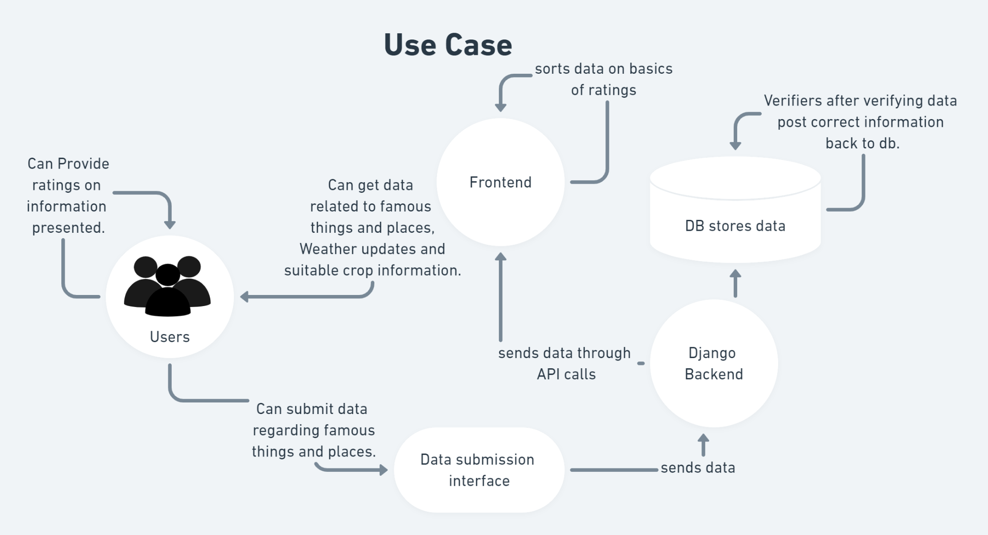

**PROJECT SCOPE**

The purpose of this document is to build an application that can travellers use for looking for the most hystorical, famous and interesting places ,monuments, handicrafts, food, sites, landscapes etc and list them based on the users location and guide them to the place through the best route

**USER INTERFACES**

APPLICATION DEVELOPMENT-FLUTTER

Backend- Django

**HARDWARE INTERFACES**

1. Smart phone with minimum 1 GB RAM

**OPERATING ENVIRONMENT**

Operating environment for the Pathik Project is as listed below.

● Operating system: Android 10 or above

● Processor: clock speed in range of 1.8 GHz to 2.8 GHz or above

● RAM: 4 GB or above

DESIGN and IMPLEMENTATION CONSTRAINTS

1. Use of Flutter for the development of the frontend of the app.

2. Firestore for the database

3. Firebase for the backend of the app

4. An android device with internet connection to run the app.

5. Deployment of model. USER INTERFACES

● Front-end software: Dart, Flutter

● Back-end software: Firebase HARDWARE INTERFACES

● Windows 10 with minimum 8GB RAM.

● Android device.

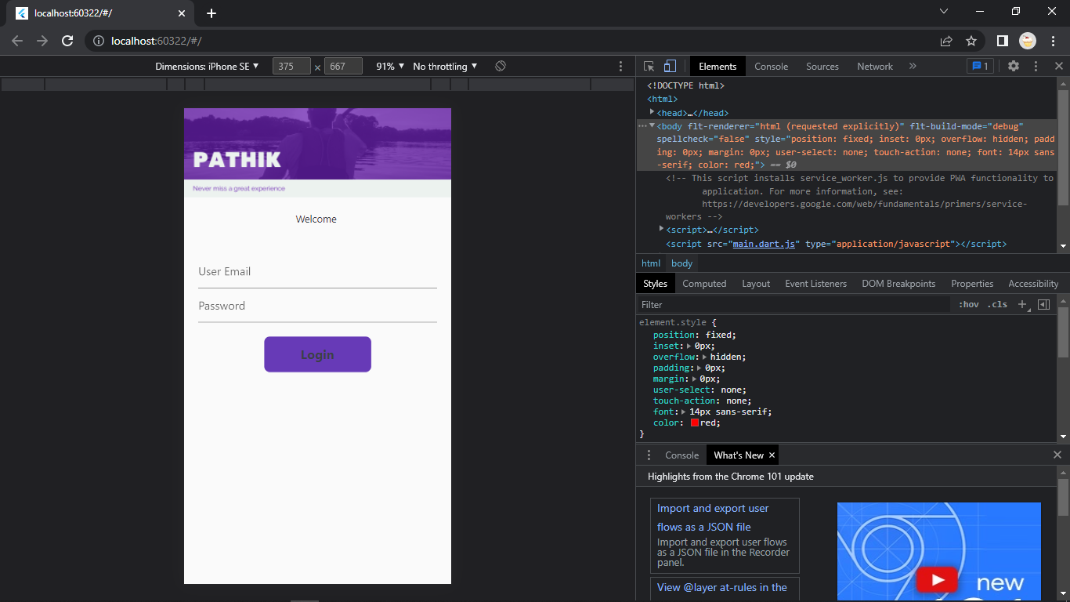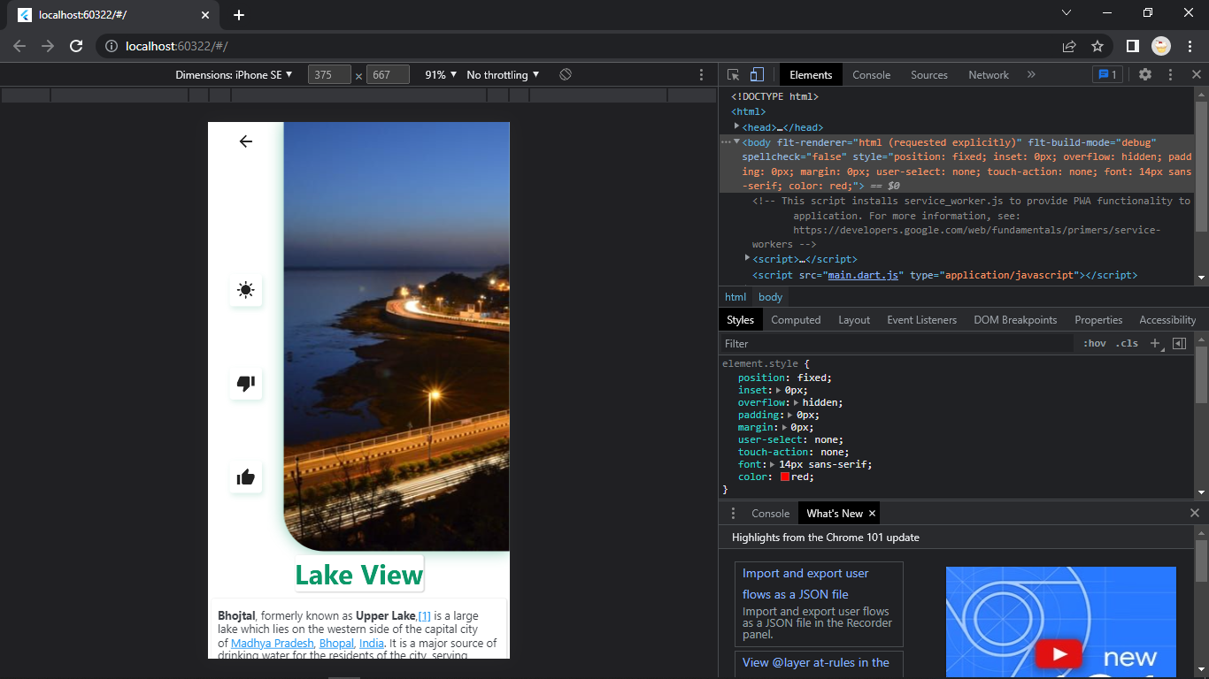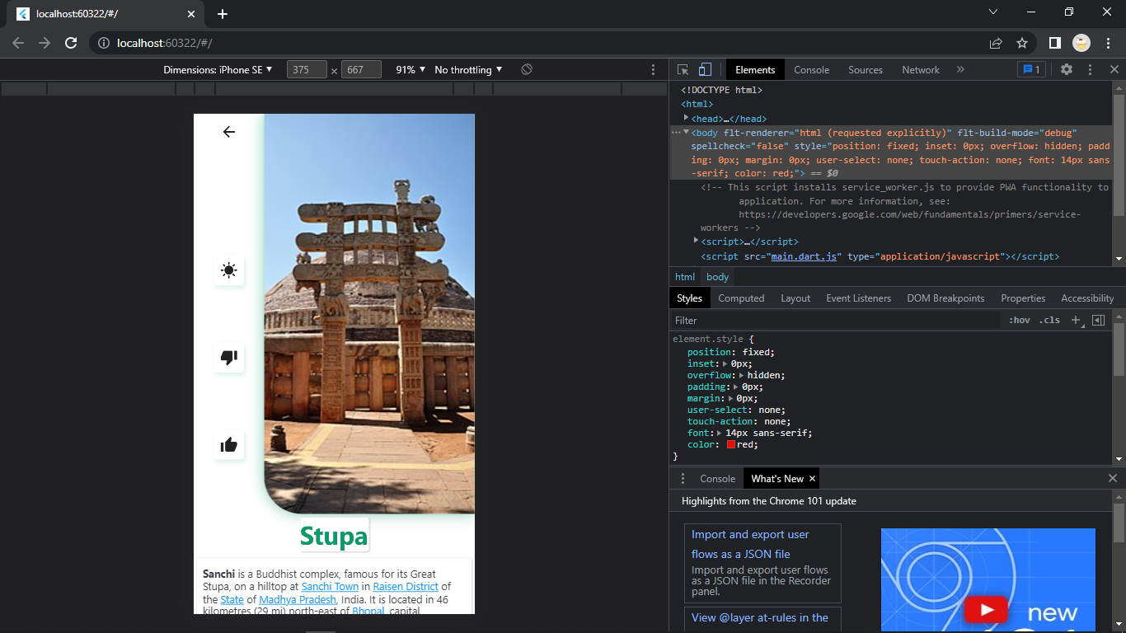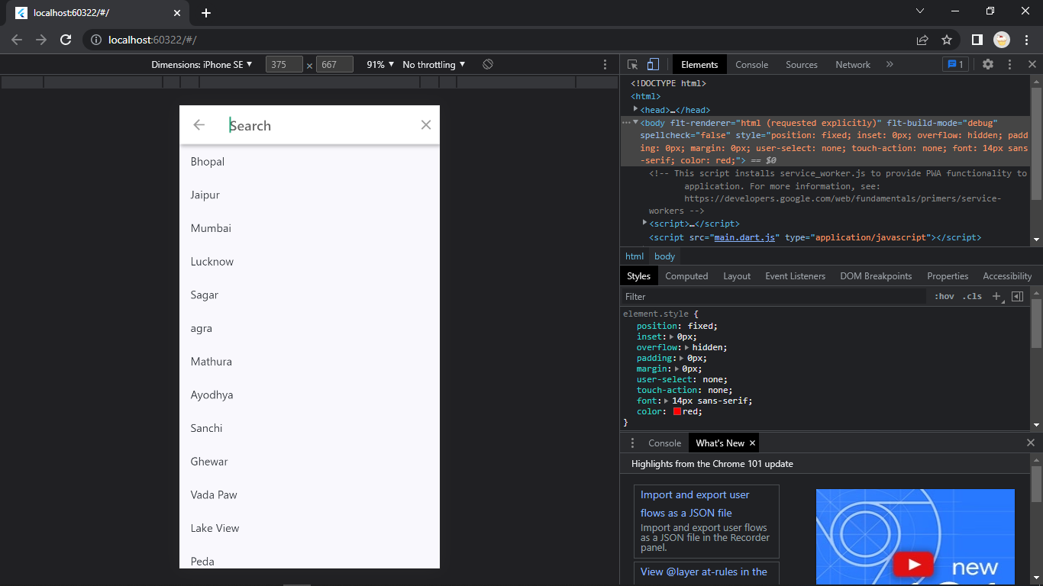

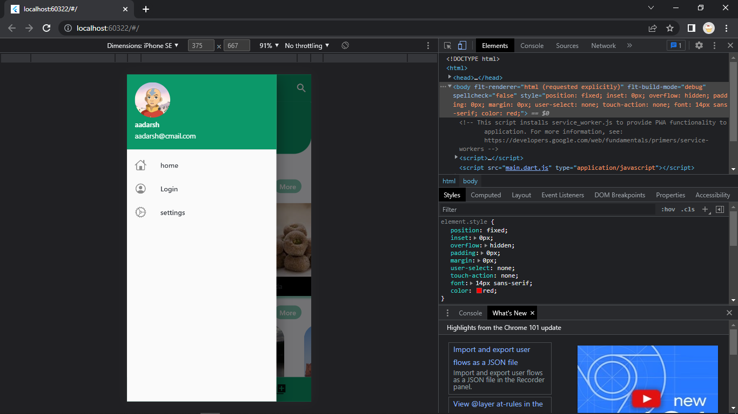

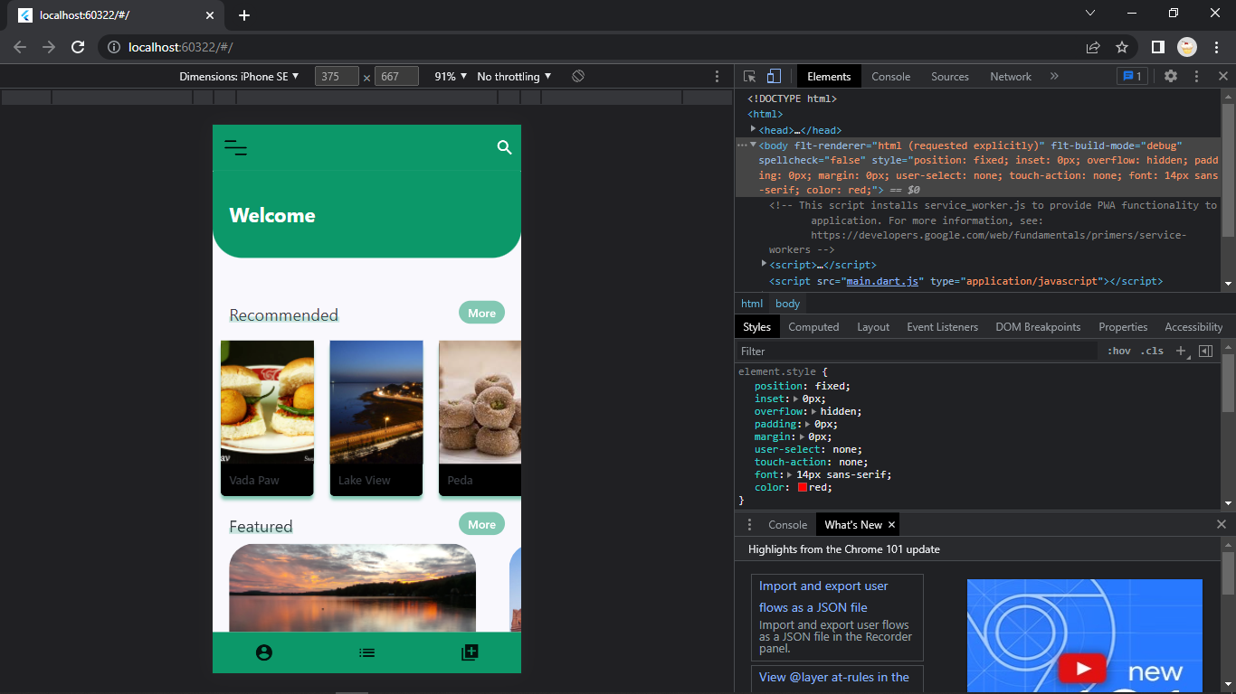

**APPROACH**

The application is developed by considering 5 the use case of the user while keeping the parameters such as user knowledge and technical constraints in consideration. The application is developed 5 using a widget centric architecture, also known as Bloc(Business Logic Component) which is an architectural pattern based on separate components. The applications have different layers connected with each other first there's login layer which redirects the user to search for place where the user wants to visit after that the user fill the visitor details in another layer after that user is directed to payment layer after which another layer generates a ticket which is in digital form as a unique QR code. 6

6 SOFTWARE PROCESS MODEL USED Agile Model Agile modeling (AM) is a methodology for modeling and documenting software systems based on best practices. It is a collection of values and principles that can be applied on an (agile) software development project. Agile SDLC model is a combination 7 of iterative and incremental process models with focus on process adaptability and customer satisfaction by rapid delivery of working software products. Agile Methods break the product into small incremental builds. These builds are provided in iterations. Each iteration typically lasts from about one to three weeks. Agile Model 7

Advantages of Agile Model:-

● Customer satisfaction is rapid, continuous development and delivery of useful software.

● Customer, Developer, and Product Owner interact regularly to emphasize rather than processes and tools. 8

● Product is developed fast and frequently delivered (weeks rather than months.) ● A face-to-face conversation is the best form of communication.

● It continuously gave attention to technical excellence and good design.

● Daily and close cooperation between business people and developers.

● Regular adaptation to changing circumstances.

● Even late changes in requirements are welcomed.

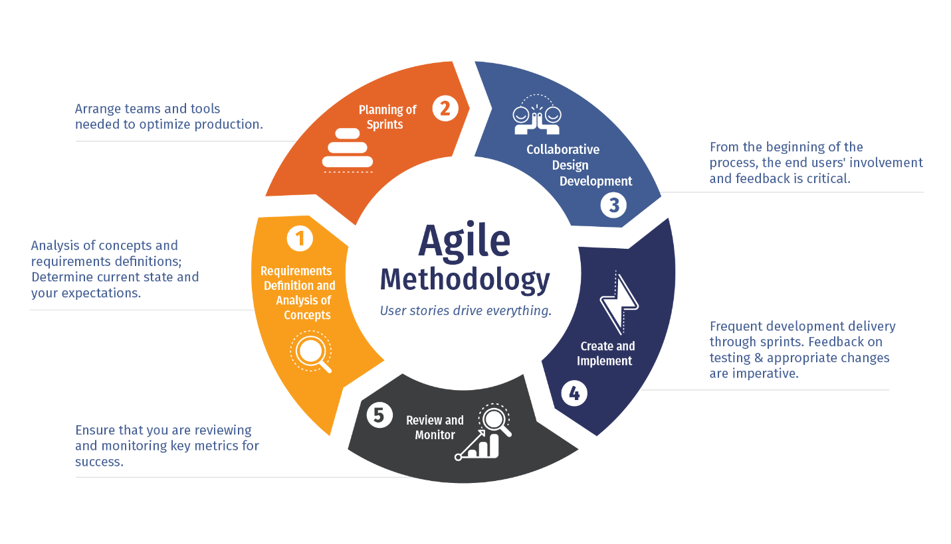

CONCLUSION

With the help of this application user can easily locate and list all th famous and historical thing like places, handicrafts food etc. It’s a flutter based cross platform application and can be used on all the platforms like andrid,ios and web